Note : I have clubbed the tasks and images.

# Task 1: Create a Directory with the Name Linux Practice

mkdir "Linux Practice"

# Task 2: Change to the directory

cd "Linux Practice"

# Task 3: Create a file named TestFile1.txt and add content to it

echo "This is TestFile1" > TestFile1.txt

# Task 4: Create a Folder named Dummy and try to delete it

mkdir Dummy && rmdir Dummy

# Task 5: Check the working directory

Pwd

Task (1-5) images

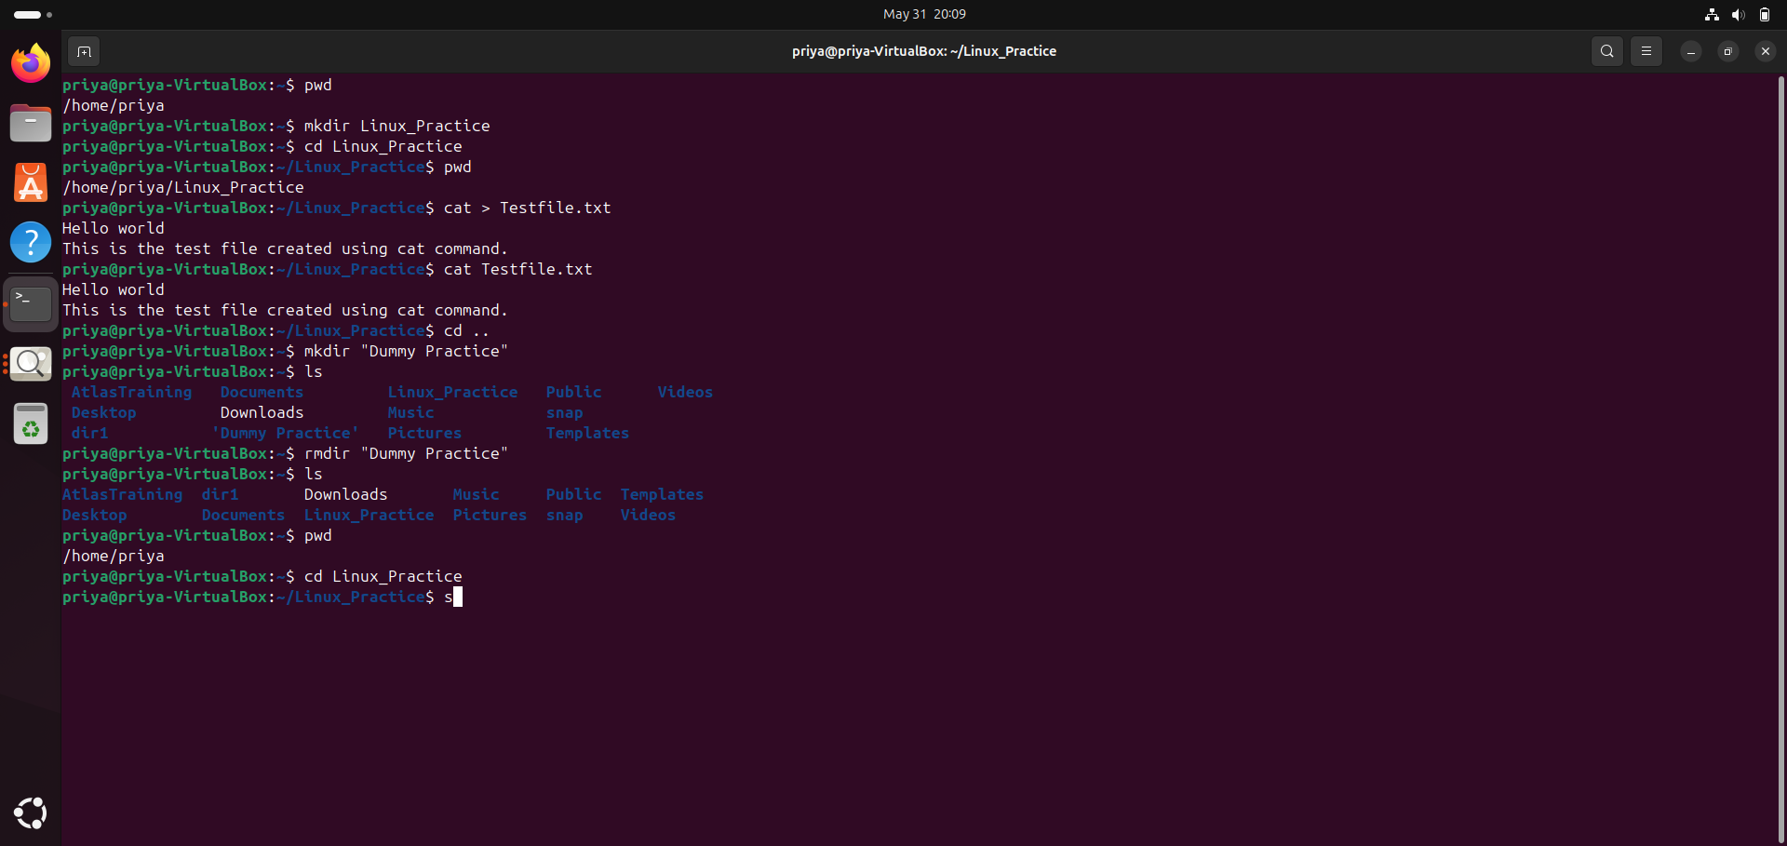

# Task 6: Check all files and directories in the current directory

ls -la

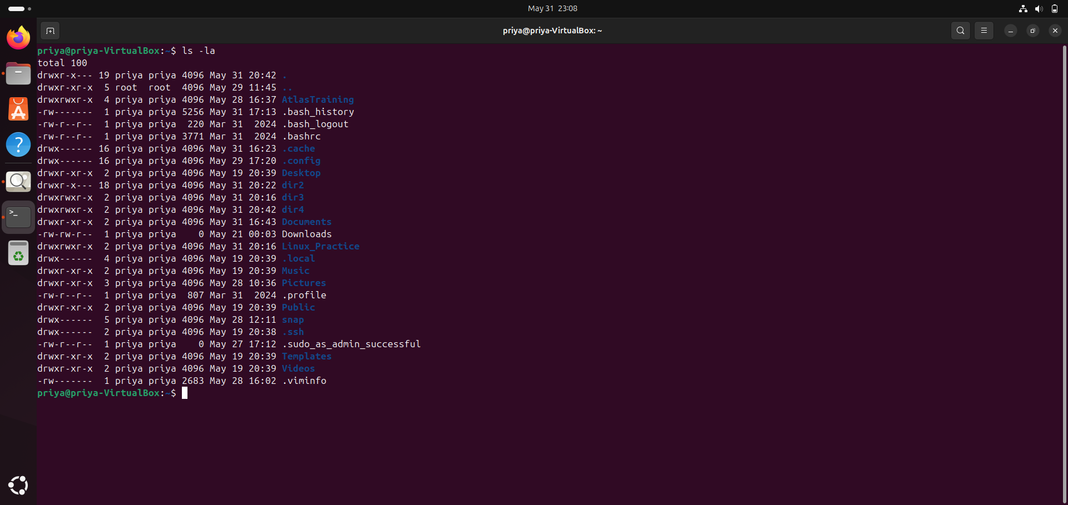

# Task 7: Create five files named TestFile2.txt to TestFile6.txt

touch TestFile2.txt TestFile3.txt TestFile4.txt TestFile5.txt TestFile6.txt

Task 8:

Copy all files from Dir1 to Dir2

cp Dir1/* Dir2/

Task 9:

Move all files from Dir2 to Dir3 (Dir2 will be empty)

mv Dir2/* Dir3/

Task 10:

Difference between rm and rmdir commands:

- rm is used to remove/delete files and can delete directories with options (e.g., -r for recursive).

- rmdir is used to remove empty directories only; it will fail if the directory contains files or subdirectories.

Example:

rm file.txt # deletes a file

rm -r directory/ # deletes directory and all its contents recursively

rmdir empty_dir/ # deletes empty directory

rmdir dir_with_files/ # will fail if directory is not empty

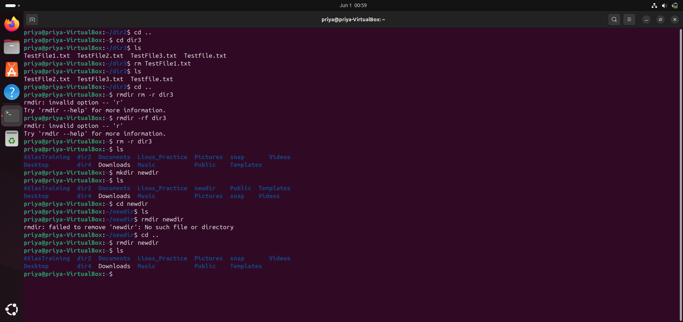

Task 11:

Use cat command to create a file and add dummy text (2-3 paragraphs of Lorem Ipsum)

cat > dummy.txt

Lorem ipsum dolor sit amet, consectetur adipiscing elit, sed do eiusmod tempor incididunt ut labore et dolore magna aliqua.

Ut enim ad minim veniam, quis nostrud exercitation ullamco laboris nisi ut aliquip ex ea commodo consequat.

Duis aute irure dolor in reprehenderit in voluptate velit esse cillum dolore eu fugiat nulla pariatur.

[Ctrl+D to save and exit]

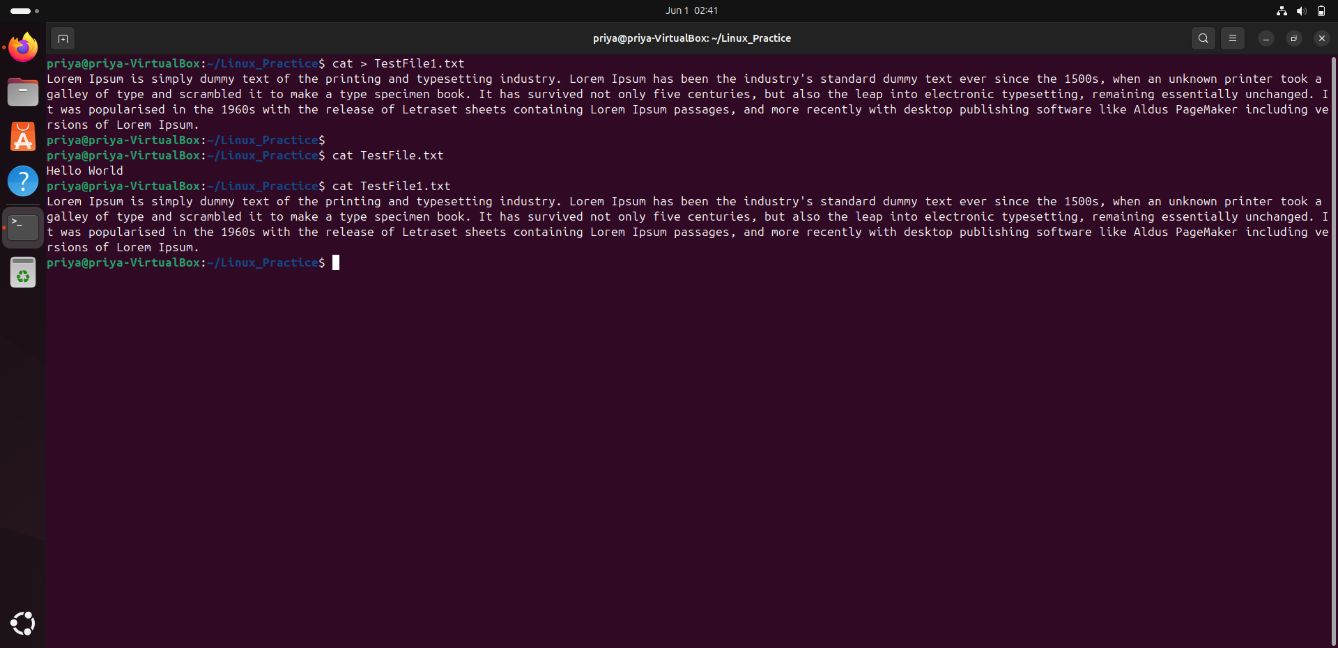

Task 12:

Get only the top line of your file (use head)

head -n 1 dummy.txt

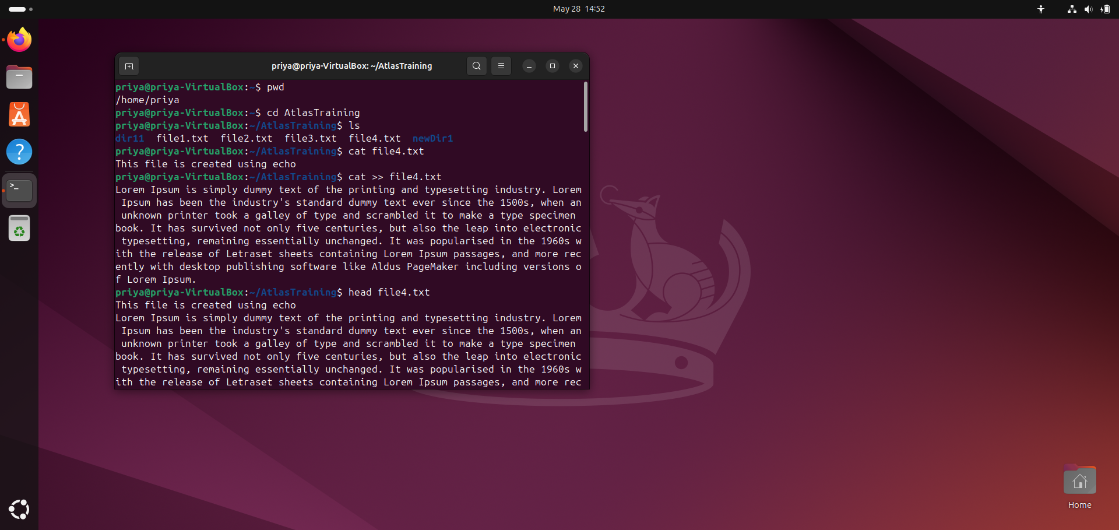

Task 13:

Get only the last line of your file (use tail)

tail -n 1 dummy.txt

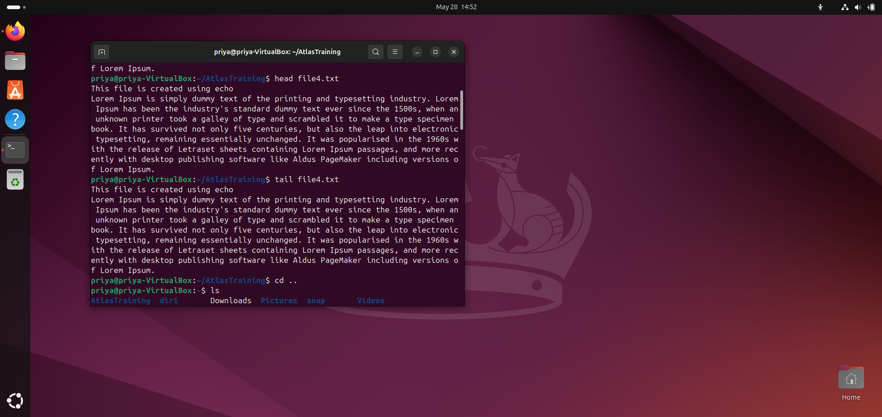

Task 14:

Plz add dummy text of 5 to 6 pages in to the same file

And

Now show the file in page by page

Task 15:

Use more command on the above file and find out the diff between less command and mofe command.

less dummy.txt  
more dummy.txt

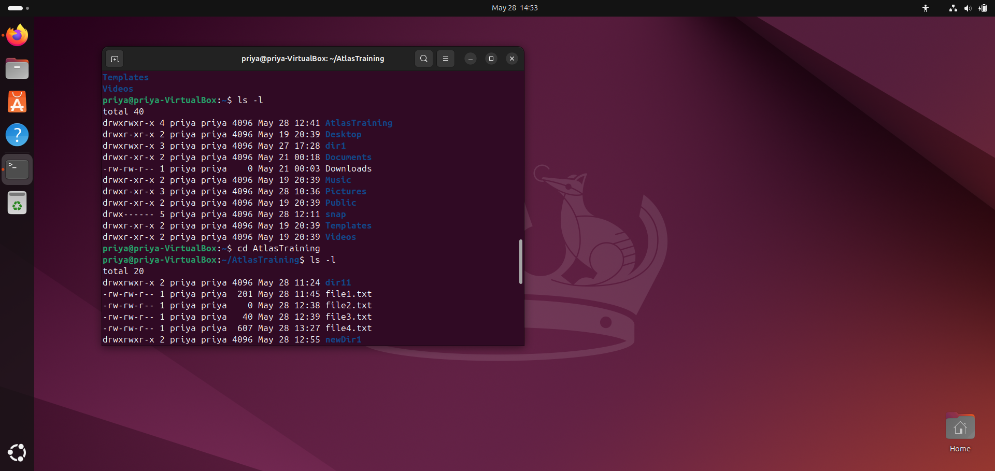

more shows text one page at a time but you can only move forward.  
less lets you move forward and backward, and you can search inside the text too.

Task 18:

Create a file using **touch** command , **cat** command and echo command and take ss (screen shot)..

Also write the difference between touch , cat and echo commands.

touch file1.txt

cat > file2.txt

echo "Hello world" > file3.txt

touch creates an empty file or updates the timestamp.

cat displays or creates file content by typing input.

echo prints text or writes text into a file.

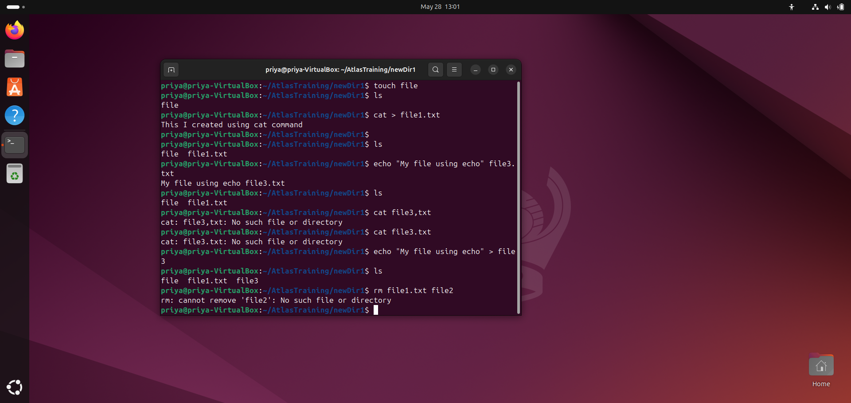

Task 16:

Can you use echo command with -e and see the diff.. Also take a ss and paste .

Using echo with -e makes special characters like \n work as new lines, without -e it just prints them as normal text.

Task 17:

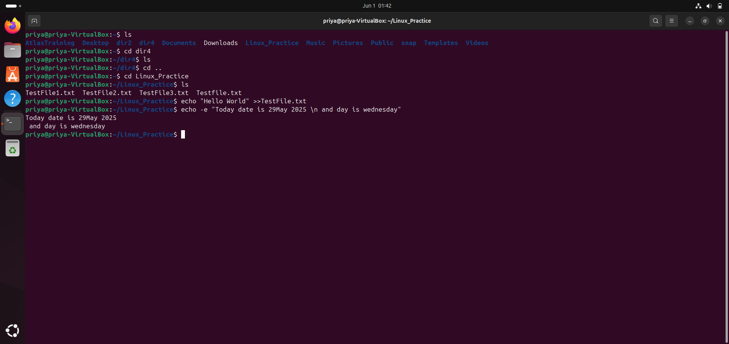

What is diff between ls and ls -l command .. ss plz

ls shows just file names, but ls -l shows detailed info like permissions, owner, size, and date.

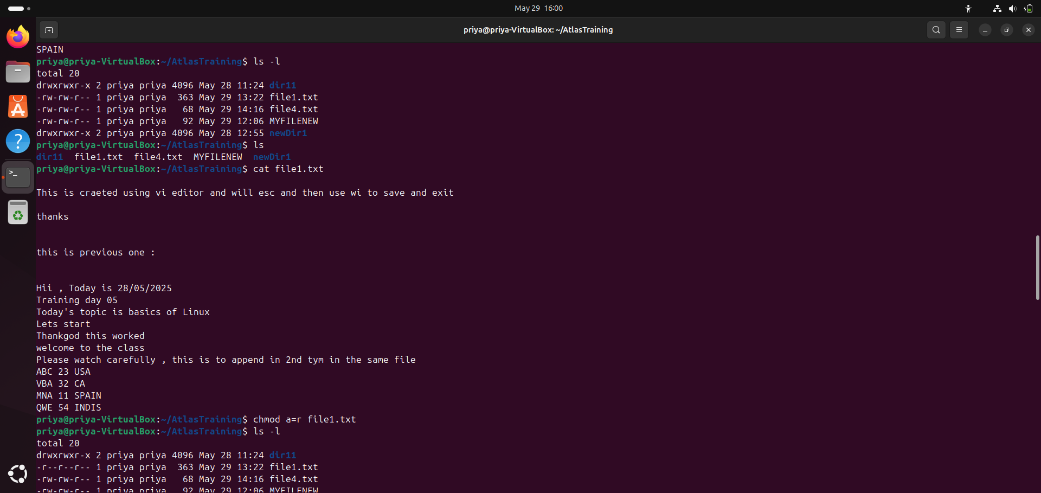

Task 19:

Can you guys try to display the calendar by using a command..

Hint: use cal  
Sudo apt install ncal

Cal 2025

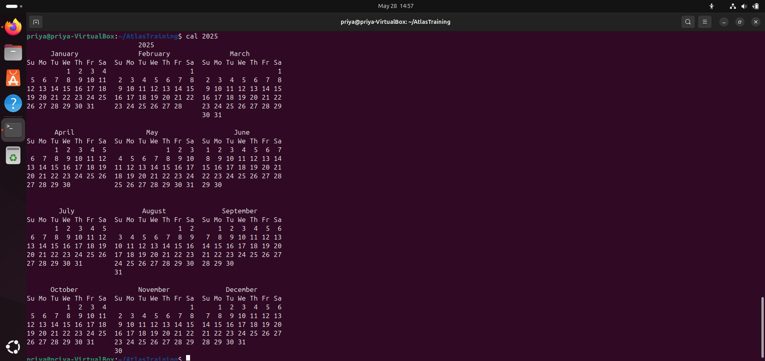

Task 20:

Can you go back to 1 directory .. at a time whats the command   
  
Cd ../

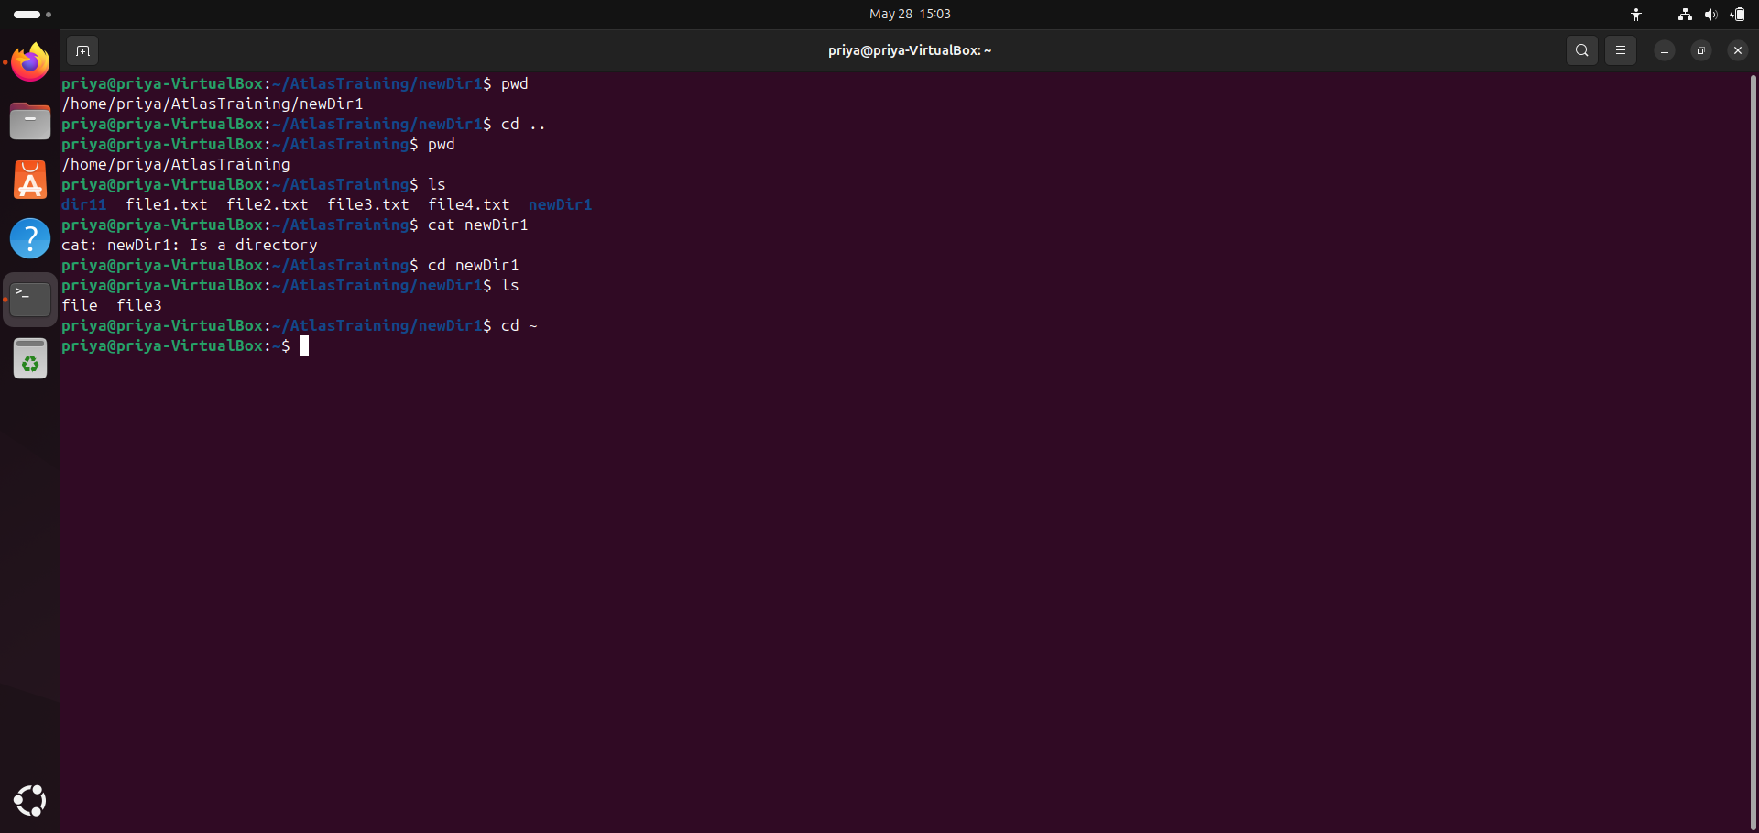

Task 21:

How to know whose user u are working on ?

Command “whoami”

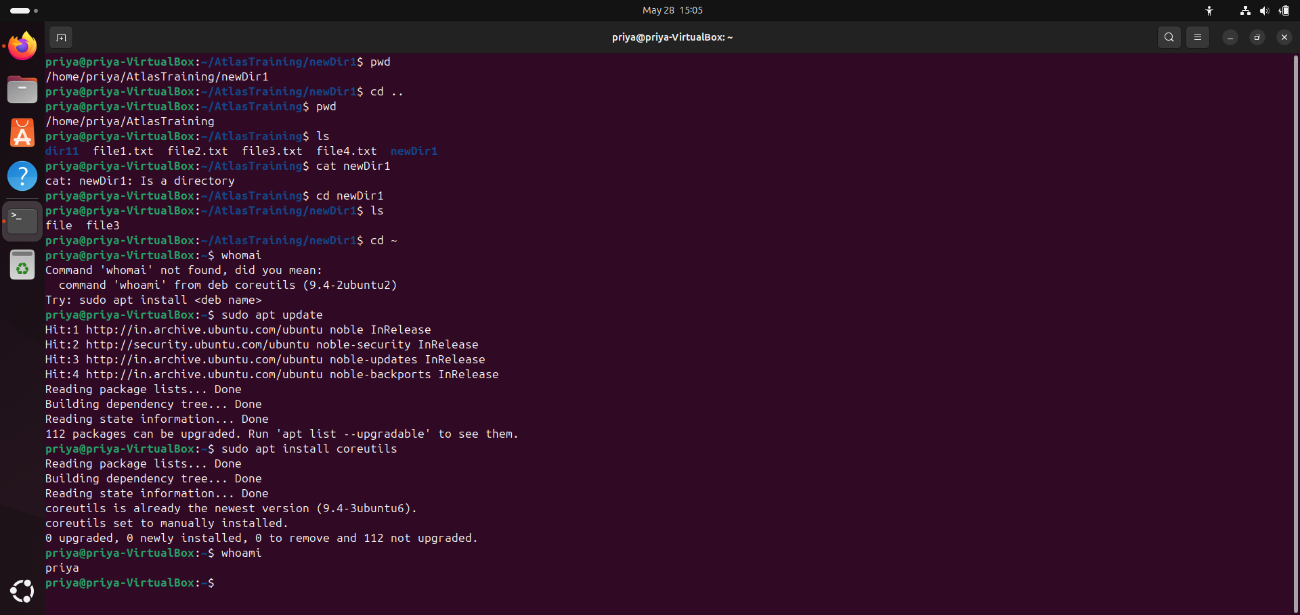

Task 22:

Try to find out who is peeping into your system..

Use users, who and w commands with ss

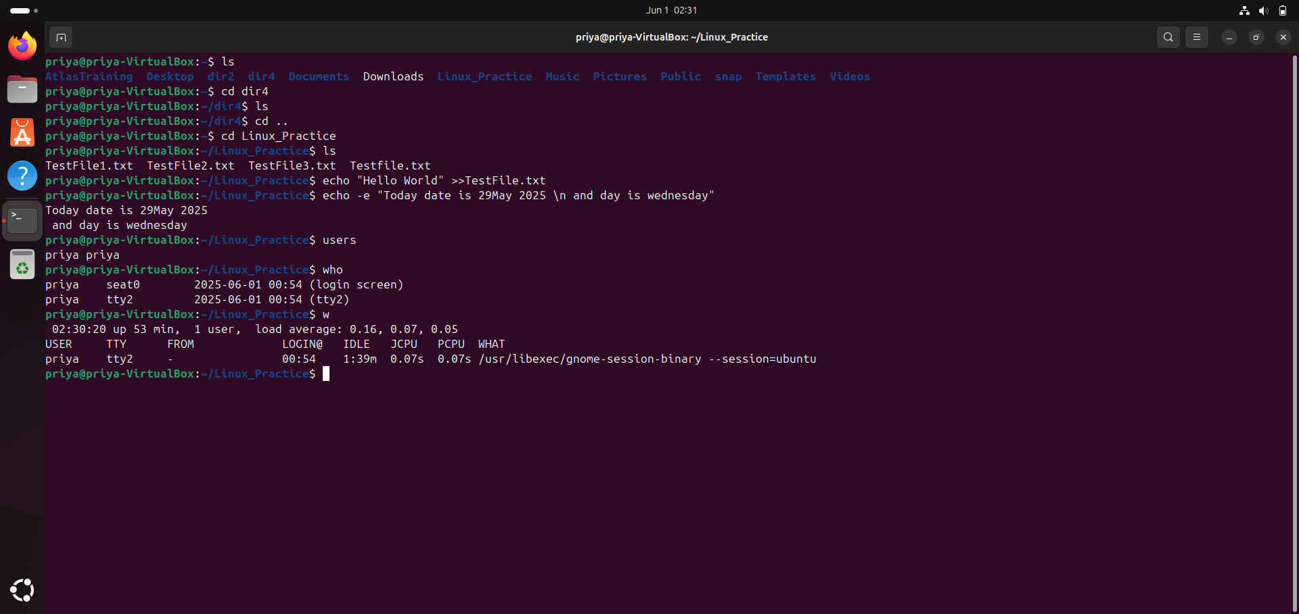

Task 23:

Can you guys try to check how much disk space is consumed..

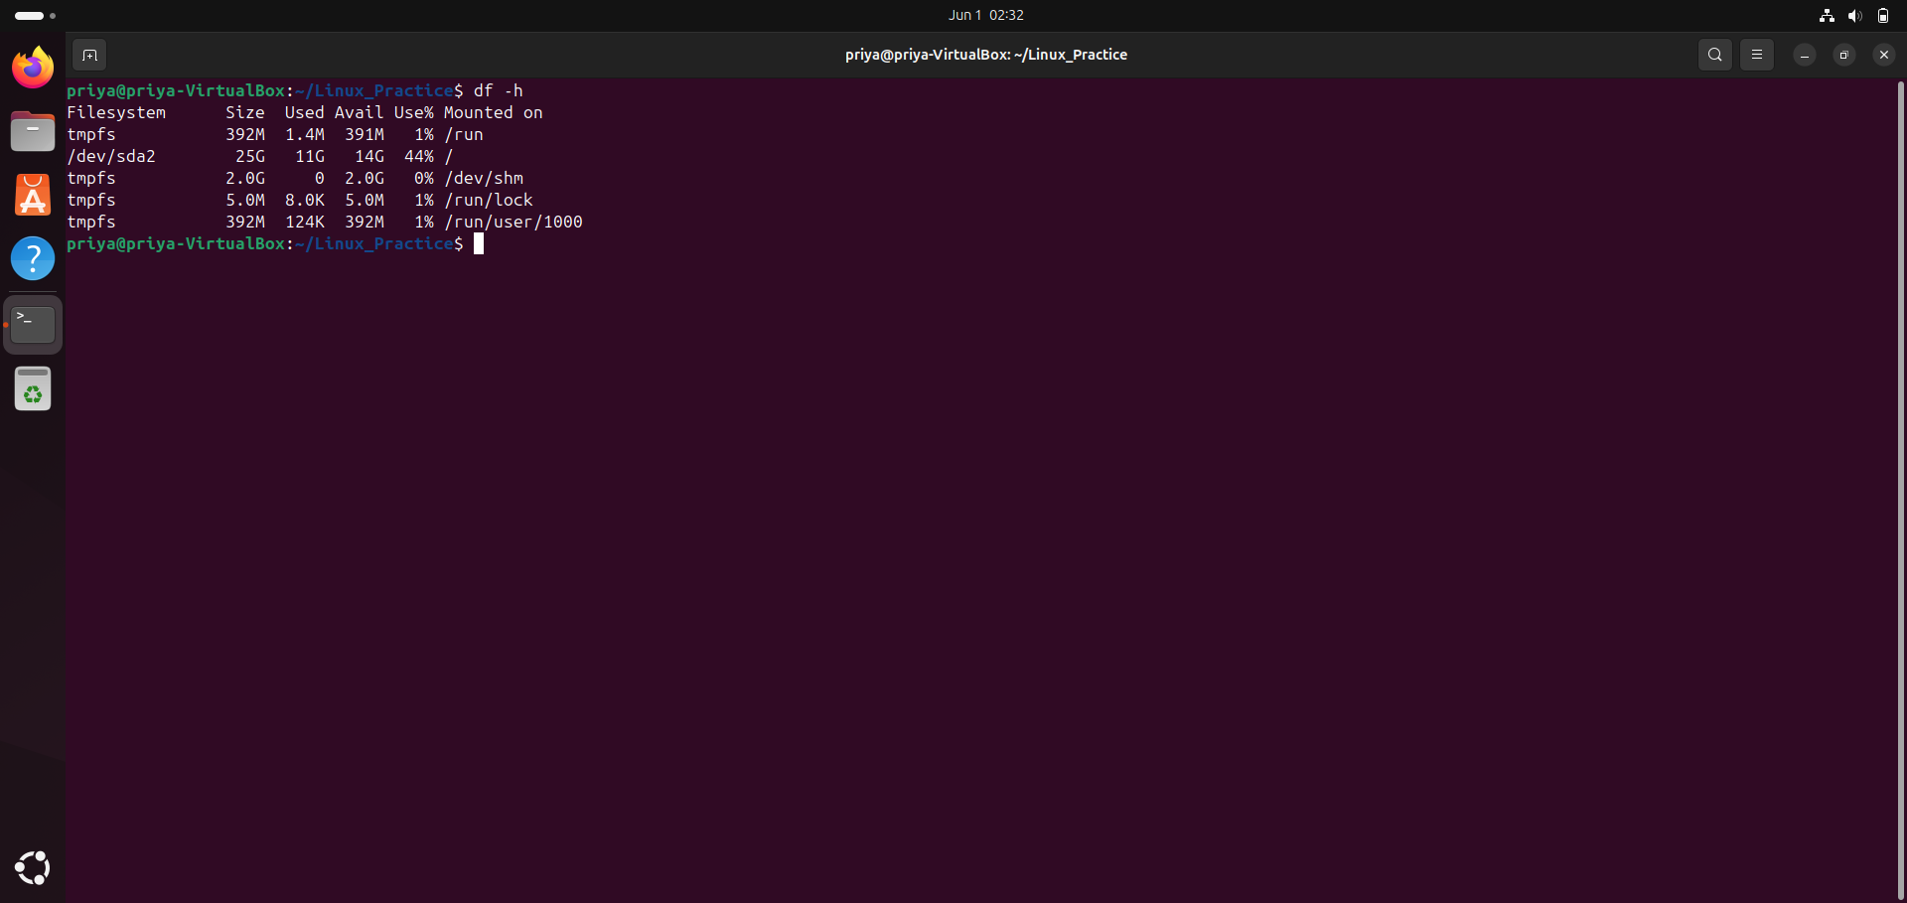

Task 25:

Find the list pf all files ending with .txt

Command :: “ls *.txt”

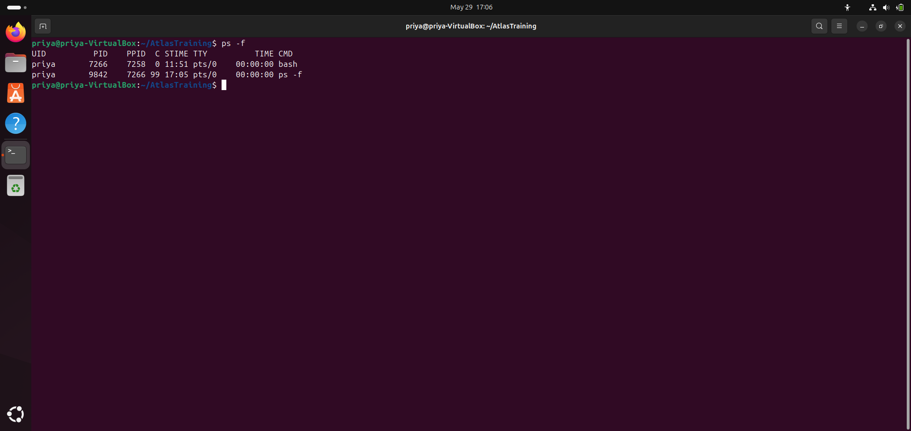

Task 26:

In Linux all the hidden files starts with . (period)

How to check all the hidden files in Linux..  
  
Command :: “ls -a”

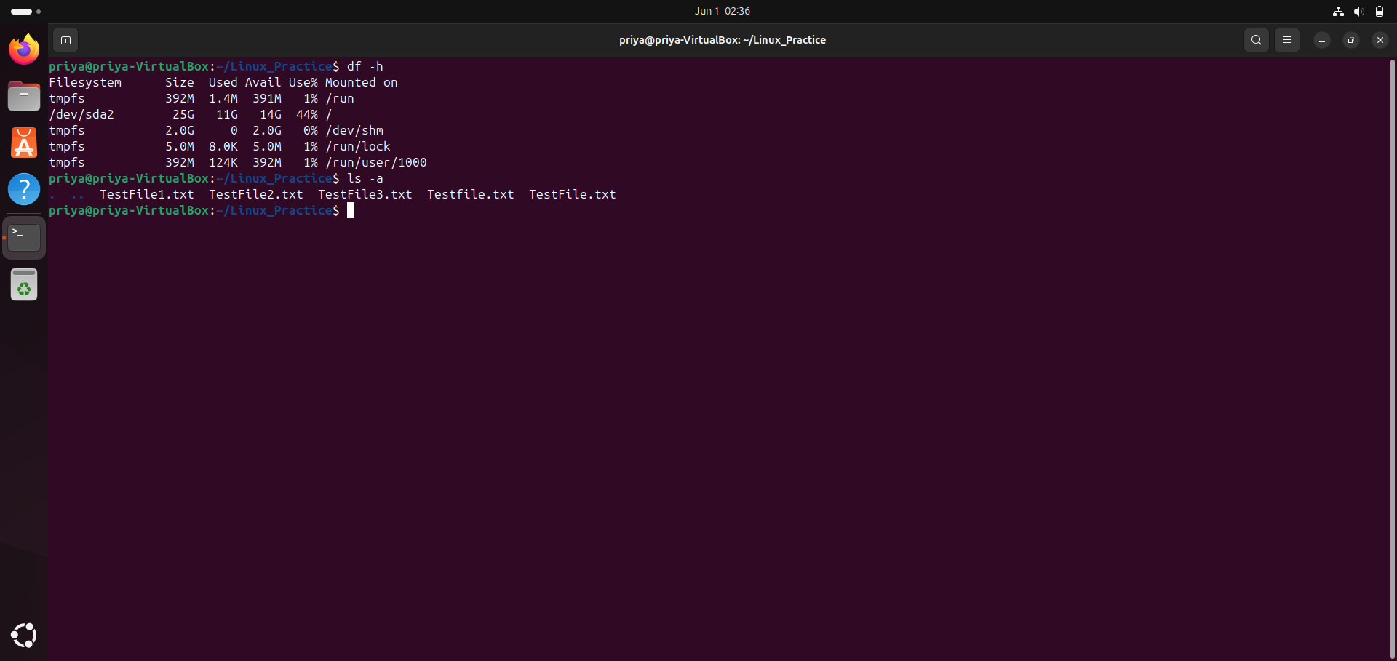

Task 27:

What is the difference between . and .. in linux

Line 1 line for each

. refers to the current directory you are in.

.. refers to the parent directory of the current directory.

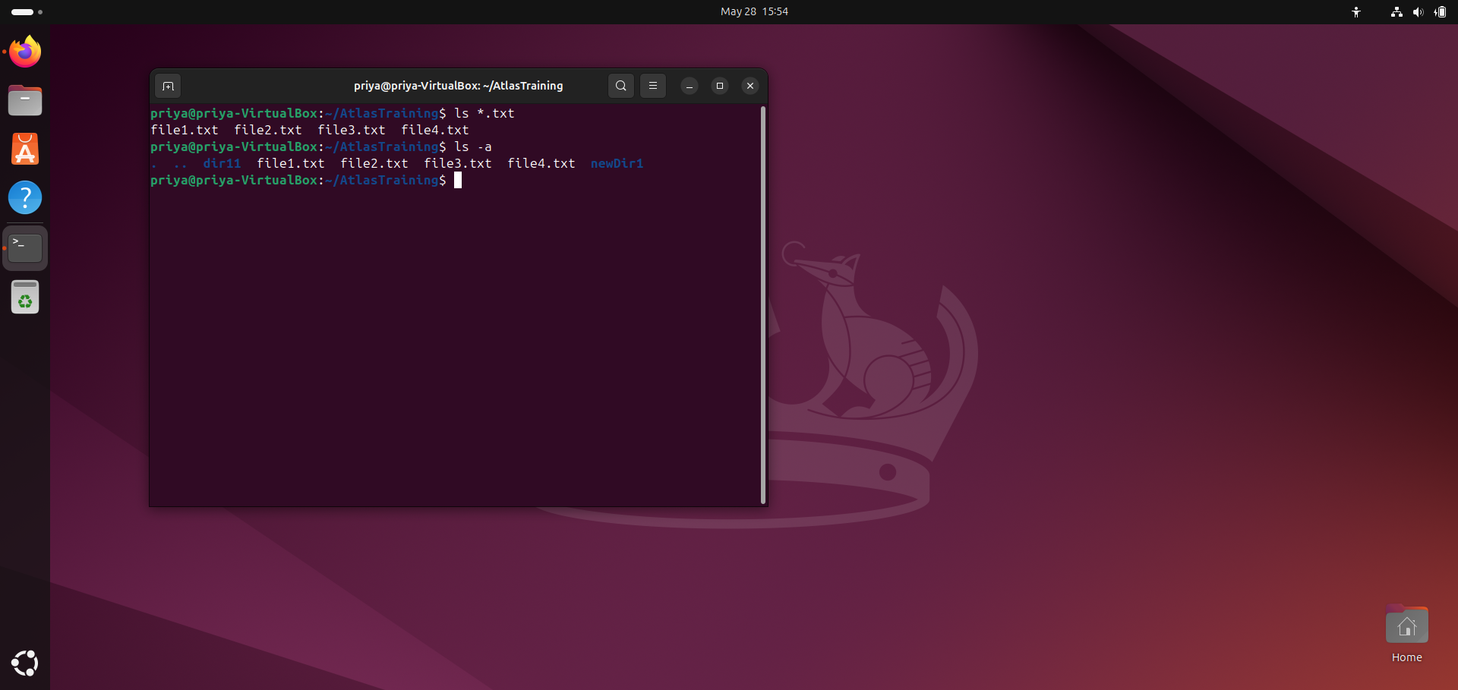

Task 28:

Can you create a file using vi editor and show the details in ss

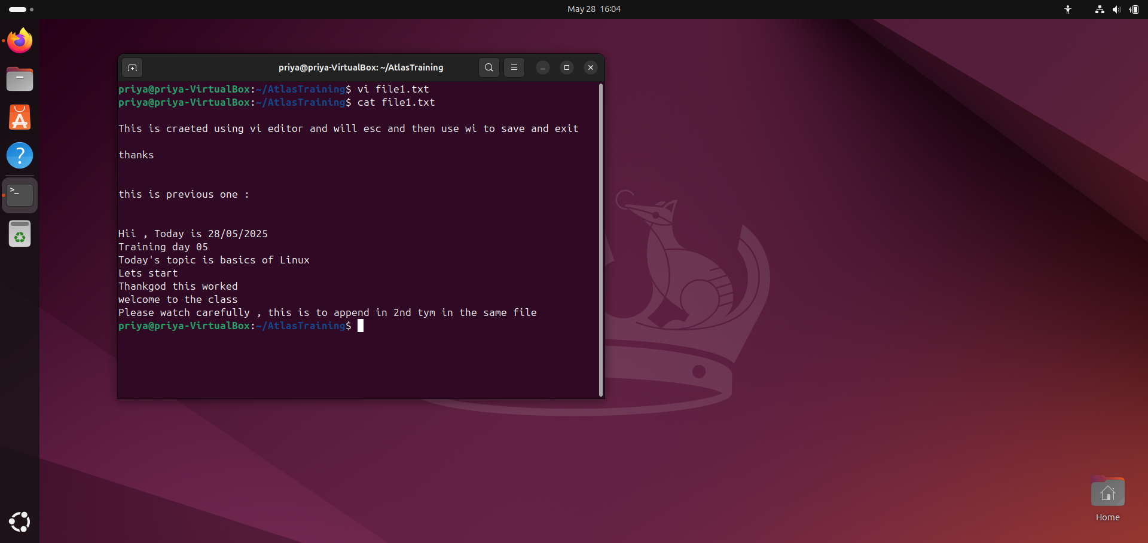

Task 29:

How to find the no of words in the file

Hint: use wc  
  
wc -w

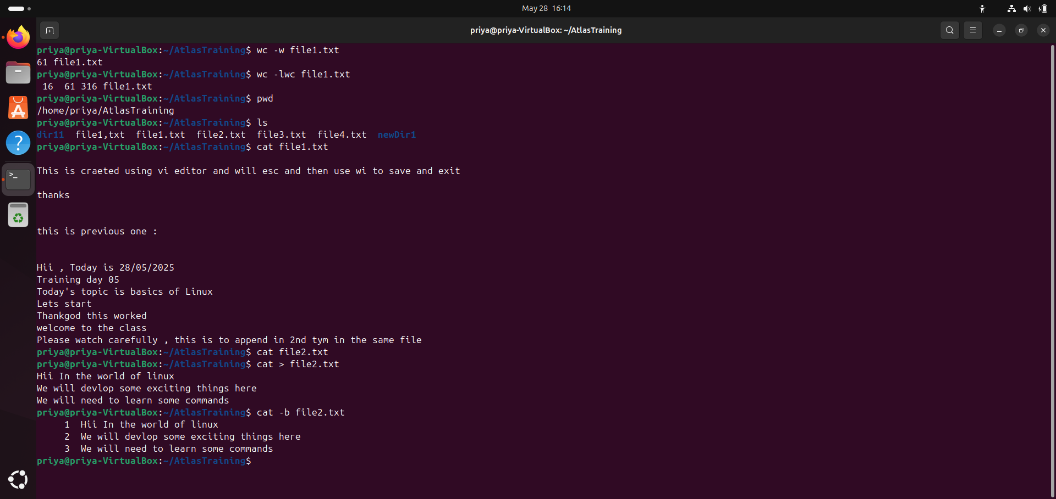  
  
Task 30:

What is the use of cat -b myfilename.txt command?

cat -b myfilename.txt displays the file contents with line numbers added only to non-blank lines



Task 32:

How to copy content of one file to another file

cp sourcefile destinationfile

cat sourcefile > destinationfile # to copy the content without copying file attributes:

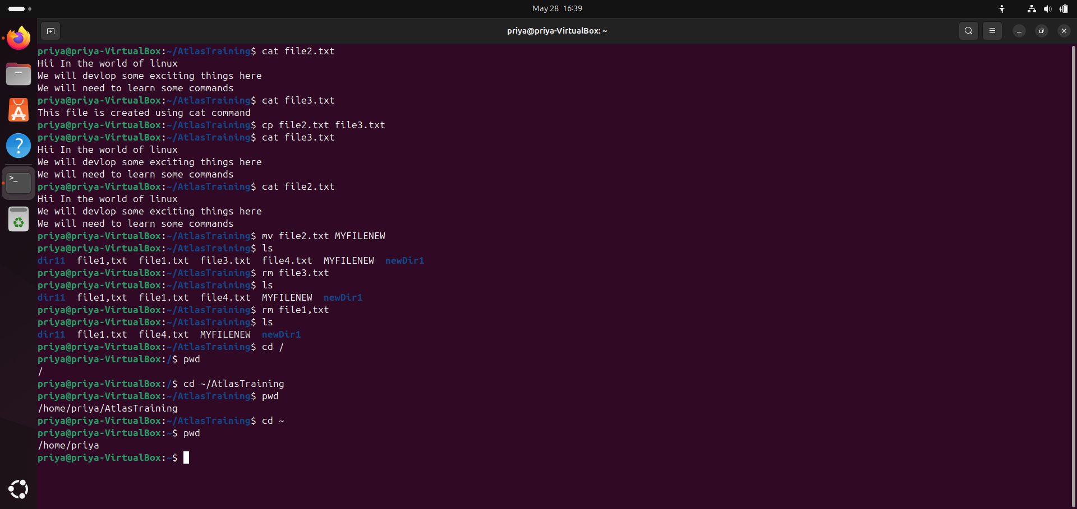

Task 33:

Now I want to rename my file with MYFILENEW can i do that if so how ?

mv oldfilename MYFILENEW



Task 34:

Can i remove or delete multiple files in linux..? How?  
  
rm file1.txt file2.txt file3.txt

rm *.txt

rm -i file1.txt file2.txt

Task 35:

In directory / slash is root

Cd / #to go to root

Task 36:

What is the way go to home directory ?

use cd ~



Task 37:

If i want to move to different users home directory

cd ~username

